

**Application Programming with JAVA**

**Course Work**

# Word Counter program

**Student ID: TMC221-297**

**2021-2022**

**Abstract:**

* Different types of compositions, whether program, digital book, or corporate writing, require a certain amount of words. There are no restrictions on the number of words or letters that can be used in multiple stages. so this program will be a great help to save time.
* Over time, it has become increasingly important because of the convenience, affordability, and flexibility it offers writers. Its interface is very easy to understand and you don’t need much time to get acquainted with the features
* Site proprietors have bounty on their shoulders and it is difficult for them to keep a check on everything. Word check is one of the foremost significant things that they have to be keep a check on when they are generating substance. It is very conceivable to keep track of word checks once you are composing the substance do that. But in reality most site proprietors don't do the same. They for the most part contract scholars and got to get the subtle elements and data from them with respect to the word check. This makes things very complicated for them when it comes to paying the author or keeping a check on the measure and sort of the substance as a entire

**Motivation:**

* Since it is free to use, you can perform word count check with the Word Counter tool as many times as you want. Whether you're a advanced showcasing pro, SEO master, author, blogger or understudy, the Word Counter apparatus will be a important expansion to your workflow.
* With the Word Counter tool, you are not limited to any specific file formats, such as Microsoft Word or Google Docs. Instead, you can copy and paste any type of text to find out how many words or characters it contains Facebook.
* You'll perform word tallying for a Microsoft Word record, Google Docs record, Microsoft Exceed expectations worksheet, scholarly expositions, as well as character checking for Google Advertisements look advertisements, Facebook posts, Instagram captions and more, all with the Word Counter program .

**Introduction:**

Whether you're an undergrad, content creator, administrator, or author, you realize that it is so critical to utilize words in a text. The reason for any letter is to make a coherent and advantageous text that is handily seen. It is essential to offer your viewpoints and thoughts adequately. When in doubt, this implies that each word has an importance, by and large it is smarter to be straightforward and utilize a base number of words. Above all else, it makes any text more limited and, in this manner, more wonderful for perusers. Furthermore, it makes it understood and straightforward, the message of your letter ought to be basic and with next to no misinterpretations.

With regards to articles, the less words, the better. We live in the data age, and nobody has the tolerance to manage enormous heaps of text. for the most part talking, any sort of composed substance contains the perfect number of words, notwithstanding of whether it is an piece, paper or novel.At the point when you are restricted by words, it settles on you more mindful of their decisions and the power they have. This assists with introducing thoughts legitimately so the peruser doesn't lose all sense of direction in unlimited descriptors.

**Software Requirements:**

* Windows 7 ,8,10, mac OS;
* Notepad++
* Filezilla client

**Hardware Requirements:**

* Intel i3, Ryzen 3 processor
* RAM 8 GB
* **500HDD**

**Code explanation:**

**package Khamidullo;** \\this code is needed to create a package.

**import java.awt.Color;** \\ this is necessary to change the color of the interface.

**JTextArea t;** \\ JTextArea is part of the java Swing package. It represents a multi-line field that displays text.

**JButton b1,b2**; \\The JButton lesson is utilized to form a labeled button that has stage autonomous usage. The application result in a few activity when the button is pushed.

**JOptionPane.*showMessageDialog*(this,"Total words: "+words.length);** \\ it lists all the codes written.

**JOptionPane.*showMessageDialog*(this,"Total Characters with space: "+text.length())** \\ and this spelling lists all the letters.

**Class Diagram:**

The lesson graph is the fundamental building piece of object-oriented modeling. It is utilized for common modeling of application structure, deciphering models into programming code. Course charts can moreover be utilized to demonstrate information.

This diagram used the most necessary objects we used in the program:

* JFrame – this creates a framework for our program
* JTextField- this creates the area needed to write the text
* JLabel- to extract words
* JButton- which works for the buttons

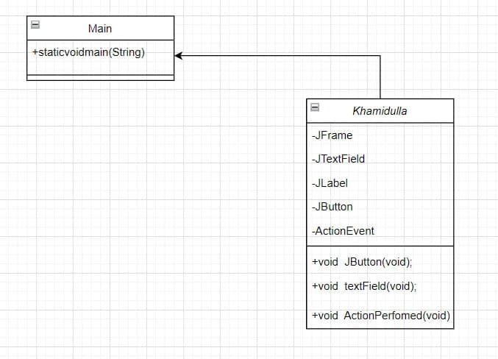

**Activity Diagram:**

A motion graph is a behavior graph that defines the motion of a frame. The action graph shows the control flow from the starting point to the end point and shows the different selection methods available when the action is performed.

* Begin – here “Begin” starts all our work;
* Register- in this area you'll be able enroll by entering data approximately yourself;
* Login - you can access the program using your stored information
* Put Words - you can type the word or copy it from somewhere else
* Press button “word” - you can know the number of words written using this button
* Press button “Character” - this button lists the letters of all the words written
* Finish- here all the work ends

# 

**Use case Diagram:**

This diagram is a graphical representation of the user’s possible interaction with the system. The usage diagram shows the different operating conditions and different types of users available in the system.

* Dial the code - in which the software engineer sorts code, creates it, and checks it.
* Upload the program to Internet - in which case the programmer places the prepared program on the Internet
* Register -in this range you will be able enlist by entering information roughly yourself;
* Create account - enter your email address
* Login - you can access the program using your stored information
* Put words – copy the words
* Press the button “Word” ,“Character” – press button

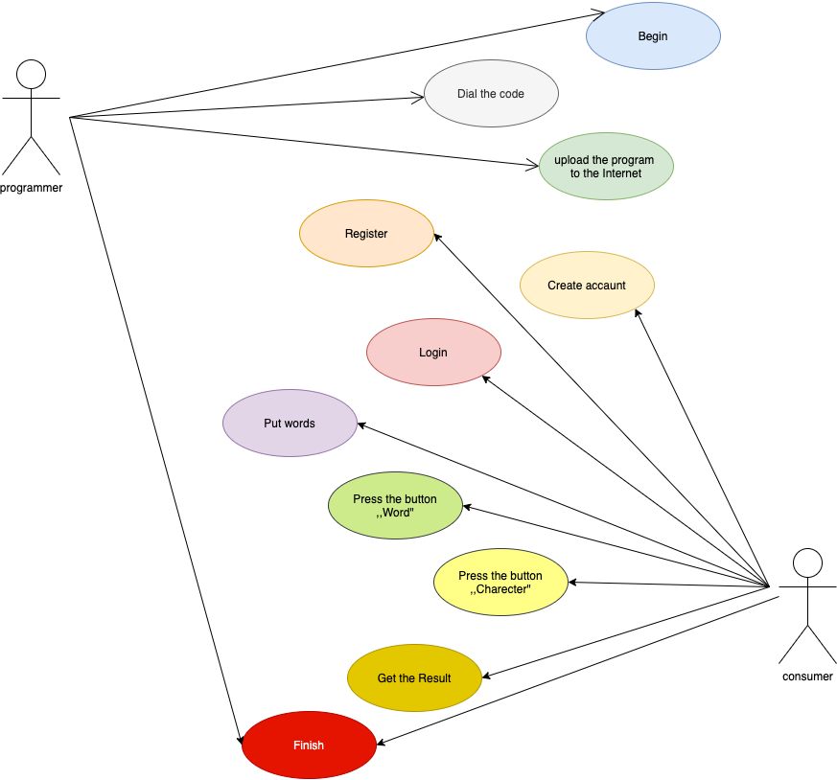

**Conclusion:**

One way to determine the number of words is to count the characters. If you still need the old calculation method, you can allow the Word calculation program to perform heavy calculations for you. You can use the word counter built-in tools to determine how many words are in a document.